**30 August 2020**

Ankit karki(Leader)

Sudip parajuli

sabin poudel

sudip ghimere

bishal poudel

Initial Project Plan

For V.R. Buidtech real estate & consultant

# Preface

This project is about building website for desktop and android app for V.R. Buildtech where this document is a project plan for the product that the team carried. This document covers the process model, plan, dividing task and what method and technique we are using. The technique we are using is agile SCRUM method. This methodology includes the sprints in which evolution of the project is done on scheduled dates to makes project dates. The audience for the project are the people who wants to own and lease the property.

Table of Contents

Preface 1

1. Introduction 3

1.1 Project Overview 3

2. Organization 3

2.1 Process Model 3

2.2 Organizational Structure 4

2.3 Organization Boundaries and Interfaces 4

2.4 Project Responsibilities 5

3. Managerial Process 6

3.1 Management Objectives and Priorities 6

3.2 Assumptions, Dependencies, and Constraints 6

# Introduction

## 1.1 Project Overview

V.R. Buildtech is a New Delhi based real estate and consultant company, which address us to develop a website for desktop and a mobile application for android. They want us to make an app and website users of the upcoming product could enter the price limit and could see the building or flat or house that comes under their budget limit. They also want us to put the notification mechanism which sends the notification or email regarding their interested type of product and the product which comes under their budget limit too. Company also wants us to link their social media channel with the website as well as with application. Company also wants the different section where the visitor on the website could enter their contact details on the first landing page so that interested prospect list could be maintained.

# Organization

## 2.1 Process Model

Agile methodology is a procedure by which a group can deal with an undertaking by separating it into a several phases and including consistent joint effort with partners and constant improvement and emphasis at each stage. The Agile approach starts with customers depicting how the final result will be utilized and what issue it will unravel. This explains the client's desires to the undertaking group. When the work starts, groups cycle through a procedure of arranging, executing, and assessing — which may very well change the last deliverable to meet the client's requirements better. Continuous collaboration is key, both among team members and with project stakeholders, to make fully-informed decisions.

As this project has been separated into different five sprints and will be covering different user stories in our project.AS the sprint is completed the useful one will be use as a part of the project.

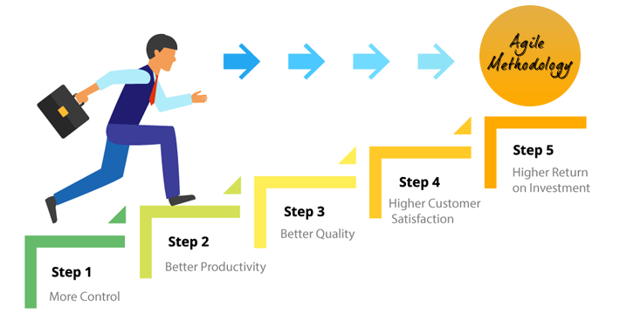

<https://www.denysys.com/blog/5-benefits-of-agile-methodology/>

Each sprint has time to finish so project will be completed in the time:

|  |  |
| --- | --- |
| Sprints | Estimated time |
| Iterative 1 | 13-08-2020 |
| Iterative 2 | 20-08-2020 |
| Iterative 3 | 11-09-2020 |
| Iterative 4 | 18-09-2020 |

## 2.2 Organizational Structure

Project manager (Abbas/Haroon)

Ankit Karki (Leader)

Bishal Poudel

(Team Member)

Sudip Ghimire

(Team Member)

Sudip Parajuli

(Team Member)

Sabin Poudel

(Team Member)

The project will be divided so that all team member has equal responsibilities toward the project. The task will be divided by project leader and assigned to every group member according to their skill. Project manager will look after how team member are going with their task and will be conducting online meeting to be inform about the task as is there is any problem or we can make update on the project before moving future so later there will be no problem. Every changes done by team member would be inform to the project manager so that later after the project is approved there will be no change in the project.

## 2.3 Organization Boundaries and Interfaces

As it is important to have good relation with the client or stakeholder where our team member will be always be doing their work within their boundaries where they will not go against the boundaries will would have bad impact to the project which isn’t accept by us. So it is responsible to our client that they should be up to date with the client requirement. Project manager will be conducting meeting with the client as well as team member whether the project is running in the right track or not. It is the important part that the client requirement is fulfilled as this project is mostly for our client so every arear should be listed or done carefully as per the client satisfaction.

## 2.4 Project Responsibilities

|  |  |  |  |
| --- | --- | --- | --- |
| Role | Name | Responsibilities | Email |
| Owner | SASBS | Providing every kind of document that are need to be done. | Ankitkarki747@gmail.com |
| Project leader | Ankit Karki | Managing the team. Dividing task to the every team member according to their skills. Look after every requirement of the project and lead the team member towards the goals.  And work with the team to meet the goals. |  |
| System analyst | Sabin Poudel | Analysing the requirement for the system consulting with clients and another related person. Help another team member in all department as well. |  |
| Test Analyst | Sudip Parajuli | Testing their data conducted in the test cycle suggesting if wrong what improvement can be done as well as collecting feedback.  Help another team member in all department as well. |  |
| Programmer | Sudip Ghimire | Coding specialist, writing the code for the application software, and looking after every program that is created.  Help another team member in all department as well. |  |
| Documentation | Bishal Poudel | Documenting the project required document that are run in the project.  Help another team member in all department as well. |  |

# Managerial Process

## 3.1 Management Objectives and Priorities

This Project aims to develop a portal for registered & existing customers to login, raise issues of concern and also monitor the reports of the daily work. The website also should list all the services undertaken by the company and used as a marketing tool for a prospective client. For the completion of the project it requires deep knowledge about the various types of tool and software that are going to be used in the project and how the team member is going to use the tools to fulfil the requirement .As there can be occurrence of conflict will impact the project where every team will be aware of that and they will be consider handling there thought that are affecting to the other team member as they have some issue will other team member they will first go with project manager and will be resolve that problem so project will run smoothly as finish in the require time.

## 3.2 Assumptions, Dependencies, and Constraints

Assumption

An assumption is what you believe to be true. These are anticipated events or circumstances that are expected during project’s life cycle. Assumptions may not end up being true. Sometimes, they can be false and it may affect your project. This adds risk to the project. As here are the some assumption:

* As all team member will give up to date about the project to the project manager so that later there wouldn’t be any kind of the problem in the project.
* Every team member should look what are the client requirement and how can we meet the goal of the client with using their techniques to make the project user friendly.
* The data of the client will be restore in the computer.
* After the completion of project the client can log into the webpage using their ID.

Constraints  
There will be consideration of time, cost and so on the project.

* The project will be finish in the estimated time.
* The project will be quality as per the requirement needed.
* Everyone will be look after the requirement time as per the material requirement.
* There will be no problem in the salary of the employee.
* The project should have minimum financial aid requirement.
* Every equipment will be supply according to save the time to maintain the time allocate.

Dependencies

* It is compulsory that employee are trained properly so that they shouldn’t depend on other.
* There should be proper supply of hardware equipment to run the project properly.
* If some problem occur they need to contact there project manager.